OCR A Level Computer Science NEA Project H446-03

Tkinter GUI Builder

Name: Ben Withington
Candidate Number: 6203
School: Kingsmead school

Contents
Analysis 3
Outline of the problem my project will solve 3
Stakeholders 4
How the problem can be solved using computational methods 5
Thinking abstractly 5
Thinking procedurally 6
Thinking logically 7
Thinking concurrently 7
Thinking ahead 8
Other computational methods 9
Interviews 10
Interview plan 10
Interview results 10
First group interviews 10
Second group interviews 12
Research 13
Example 1 13
Example 2 13
Example 3 13
Essential features for computational solution 13
Limitations of computational solution 14
Requirements 17
Hardware 17
Software 17
Success criteria 18
Design 21
System diagram mind map 21
Justification for decomposition of solution 21
Opening window 21
Menu bar 22
File 22
View 23
Settings 24
Usability features 25

Analysis

Outline of the problem my project will solve
The project I am creating will simplify programmers’ lives a significant amount by giving a graphical interface with widgets and other tools that allow you to design a graphical user interface (GUI) by dragging and dropping normal Tkinter widgets or new widgets that can be created. This will also help companies by allowing anyone to create the design of a Tkinter graphical user interface. This is a problem currently due to the issue of in businesses there tends to be a design team and a programming team when making GUI’s but currently the programmer still is required to create the designs to a close approximation to the design team’s designs. This can be extremely complicated due to the complications of different positioning systems in Tkinter as there is a choice of grid, pack, or place. With my program this complication would be mitigated as the design team will be able to place all the widgets on a preview of a Tkinter window. This allows the programming team to then be required to just do the backend as the Tkinter GUI builder will output a Tkinter window or windows that perfectly resemble the designs of the design team. Also, this could allow full stack developers to be better at what they do as they will be capable of creating any front end of an app due to it being easy to use and very professional looking.
One of the features of the project will be a side bar or a tab menu from the main menu bar that contains symbols that when hovered over represent different tools that are each widget the program supports. These tools should at least contain all the main and simple widgets in Tkinter like frames, labels, buttons, and entry boxes. Once one of these widgets is selected there will be a preview of the widget in a configuration bar on the screen that will contain all the features that can be changed for any widget by using sliding selectors or colour pickers or dropdown boxes. Once the appearance of the widget is complete there will be an apply button which will place the button on the screen or the selected frame for it to then be dragged around or adjusted. The appearance of the widget can also be adjusted later again, allowing for a user-friendly system that makes this complicated process that previously could never fit the initial designs now fit perfectly. For widgets such as buttons I may also include a feature that will bring up a window if you right-click and say add on click as this allows the designers to attempt to program the backend or at least write comments as to what should be included in the backend. Also, as the system will be so adaptable and easy to use it could even be used by the backend developers to make a design similar in quality to that of the designers and if they do this then they can program the whole logic as well as the design on one system to produce a perfect Tkinter file.
This therefore solves the problem of app designs not turning out the way they were intended while also making the process of positioning widgets much simpler making them no longer require professionals. This benefits companies as it means they only need to hire programmers to make the backend making the process of app creation more streamlined and manageable.

Stakeholders
This application will be used by many distinct types of people as it will mostly appeal to workers wanting a better environment to put their visions into reality as this application can perfectly recreate their designs in a Tkinter program. However, this is not the only audience as it will also be appealing to people wishing to learn how to use python and Tkinter by allowing an integrated development environment that allows for creative design choices as well as the ability to program the backend. This therefore caters to anyone wishing to expand their programming knowledge or to anyone wishing to complete their design projects whether they are professional and for business or just personal it allows everyone to use python in a straightforward way not requiring any knowledge to design it. However, it does require someone with knowledge of procedural programming to help create the backend of the graphical user interface designed.
This might as well catch the interest of teachers as they may be able to use this program to teach students how Tkinter can show widgets on a screen or how Tkinter can be used to create detailed and complicated GUIs by using my application. By using this application, it will make the lesson creating process much quicker whilst simultaneously teaching young computer scientists how to program quickly and easily.
For my stakeholders I will choose at random one teacher from my sixth form as well as one adult working in computer science who may be interested in using this software to make the process of creating a GUI quicker. This will give me reliable results as to how I should continue making my project and how the intended audience would receive it. Later in this report I will therefore conduct a survey asking a set of questions to these stakeholders to see their opinion as to whether they would consider using it and if they would want to add or remove or modify any features of it.

How the problem can be solved using computational methods
The problem can be solved using computational methods as the problem at hand is that due to the current system of designers drawing diagrams for the programmers to attempt at replicating in Tkinter. However, this often will not go smoothly as it can be exceedingly difficult to replicate such designs in Tkinter so with the new system that difficulty is removed using computational methods as explained below.

Thinking abstractly
Abstraction is the act of removing excessive details to arrive at a representation of a problem that consists of only the key features. The project has qualities that can be solved using this definition such as:
- This removes the extra time needed to design mock versions as it can all be done online on the GUI builder. This is done as it allows the design team to collaborate, and it removes the need for even more applications the company relies on. If the company relies on less outside applications, then they have less dependencies and reliance in case one of the systems fails. To achieve this the project should be remarkably similar and no more complicated than the normal design applications they would usually use.
- The GUI builder will be made to remove the need to remember all the Tkinter syntax for each widget as the widget’s creation and positions will all be calculated and written by the system. This therefore removes the need for the designers to know all the syntax so that then designers who are highly creative and artistic can create a Tkinter file without knowing how to program. This means that the company can create applications at a greater rate as the complexity of potentially non artistic programmers will no longer need to attempt to recreate the designers’ designs.
- Also due to the feature of allowing the backend to be possible to program in the GUI builder that means that the company no longer must invest in a complicated integrated development environment just for Tkinter apps. This reduces the costs for the company, and it is an abstraction as it simplifies the issue by making it all accessible by only needing the understanding of one application.
- Another abstraction that this solution creates is the fact that this one application will do everything and write a Tkinter file to perfectly replicate the design which no other program does as the only similar system requires an open-source external python program to transform the design into Tkinter whereas mine removes the need for multiple resources and does all the computation itself.

Thinking procedurally
Thinking procedurally is to analyze a problem by looking at everything that is needed to solve the problem. To do that the main problem must be broken down into small problems or steps taken to achieve the goal. This is called decomposition where I will analyze the project and plan each step required to achieve the result and each feature step by step.
- The program will start with an open window asking where to save a directory for all the GUI designs you create. This will also contain a title and a logo as well as a little summary of the program with a help menu accessible on the display.
- Once you have created a directory then it gives a blank window initially set in a light theme which will be adjustable to preset or customizable themes. This will have all the bars like the widget bar and the configuration bar and the menu bar that each contain tabs to have many features that the software can do. Currently as there is no project all the buttons will either be hidden or grayed out so that they are disabled.
- Next the user will open a new file and then a white screen will show up and it will be resizable, and it can be zoomed in and out from as this will be the screen for the GUI.
- The user can then drag widgets from the widget menu and drop them onto the screen in the user’s desired location. Afterwards, as that widget is still selected the user can edit the appearance or functionality of the widget to suit their needs.
- In this configuration bar the users will have the option to edit the widget in real time on a preview widget in that section of the GUI as this will allow the users to see exactly what every customization feature changes when it comes to their GUI.
- The user will also be able to right-click on a widget and open its source code to either change the Tkinter of a label or to open the onclick command of a button to try to edit that and change what happens when a button is clicked.
- Another feature will be that if the user wishes they can show all the source code so they can edit it all together as every button or widget will have relevant and normal variable names.
- After completing their GUI with images and buttons and entries and any widgets available they can either save it to continue editing it in the future or they can export it as a Tkinter file so that then they can use it as an application used throughout the company or for the company to sell.

Thinking logically
Logical thinking is an important feature of the program as it is the buttons pressed and the opportunity for unique designs never thought of before that is the goal of my project. Many distinctive features will allow this to happen like the class in my program that will turn what the user sees into Tkinter that will have every single pixel perfect.
Some of the logical features implemented where the user can decide the program flow are as follows:
- Every widget dragged onto the preview window is a decision made by the user to alter the flow of the program. This is because the addition of widgets makes the program unique and unlike any other GUI designed and built on my application.
- There will be an exit button at the top of the screen that allows the user the ability to leave the program, and this changes the flow of the program as it will cause it to run a method in the menu bar that will save everything and then close the application.
- There will be a menu bar at the top of the screen that will give the user the ability to save files or select widgets or change the theme in settings or many other things that allow the user to adapt their experience using the application to their own needs. This changes the program flow as it will cause it to access a class that allows the user to alter the theme of the builder not the file they are building. This makes the experience better as it also makes the flow of the program different for each user.
- There may be a feature where the user will be able to move the widget bar and configuration bar around the screen or they will be able to find preset formations of the bars in the main window. This makes the user potentially find it easier to use as it will be formatted in a way that the user understands and can be used quickly and easily. This changes the program flow as it not only changes the position of all the buttons and tools, but it also changes the position of the preview GUI. This means that every user version of the application is different as to how they prefer it.
- When the application is opened for the first time there will be a decision for the user to make as the program will ask where to save the project files and depending on here, they choose to save It or what they choose to save it as will alter some of the code. This therefore makes the flow of the program different for each user as it allows the user to edit where they want everything saved making the location that the application uses to get data from different for each user.

Thinking concurrently
Concurrent processing is when a computer processes multiple things at a time or makes it appear to the user that multiple things are being processed at one time. To achieve these techniques like having an update method in each class so that all the attributes of each class are updated at the same time. Also using the feature where the user can open a source code screen, they should be able to apply cosmetic features to multiple widgets all at once. These show concurrent processing as it is the appearance that multiple processes are being executed simultaneously as this will increase the efficiency of the program and reduce lag for the user trying to create GUIs with the application.

Thinking ahead
To think ahead I will try to analyze what inputs outputs classes and maybe some methods I will use to achieve a coded solution to my problem. This will help with the production of the application as it means early in the creation of my project I will have already thought about and planned some parts of the program. This will only be the first draft of some attributes possessed by the application so they may change but having this insight into the future of the development process can assist in completing it as quickly and as efficiently as possible. This is because when it comes to designing and implementing my program I will already know where to start.
Inputs:
- The mouse will provide many of the inputs such as pressing buttons or dragging widgets or picking customization options for a widget are mostly going to be taking advantage of a mouses capabilities.
- A keyboard can be used to add text to the screen or change some cosmetic features like the colour by typing in the hex colour code. Also, a keyboard will be used to type in any python code needed for the backend side of the GUI.
Outputs:
- This program will have one main output which Is the completed python Tkinter program that can be used to do anything like for a password system or for a calculator or anything. This is the product that could be sold, or it could be used along with some backend to create a good application for a purpose.
- There will be an additional output which is any in progress projects as these will be saved as either a Tkinter file with all the visuals programmed in so that the preview can have this program displayed on the editing window or maybe a pygame window just because in pygame the same images can be presented in the same way but updating the preview will be much quicker and smoother. Also, in this directory there will be a core python file with a lot of functions all used for buttons or the main program that will be separate but when the full Tkinter program is exported they will be combined.
Classes:
- One class that I will have will be the preview screen as I will need methods to initialize it so that it can detect if the mouse is hovering over it with a mouse button down implying that they have dragged a widget. This class will also need methods to allow the widgets to be changed to size very quickly and easily as well as the exact coordinates being saved in a dictionary or array as I will need the ability to detect mousebutton presses.
- Another class I will create will be for a tool bar at the side of the screen which will be inherited by the widget bar and the cosmetic bar. Both will be separate and together if I can design a system to create the classes that have inherited as tabs on the main parent class.
- The opening window asking where all projects will be saved is another class I will create as this needs to be able to run at any time and this can be done using an object-oriented paradigm.
- I may also have another tab that can be added to either of the tool bars that shows each frame that has been created and the widgets on each frame as this will allow experienced professionals to see how the application designs GUI’s so that if they wish to edit it they can. This will have methods that allow the user to move the order of the widgets contained in root or in a particular frame around. Also, I will have a method that allows each widget in the preview to be made visible or invisible.
- There will be more classes in the end solution, but this is a brief example of a sample of some of the planned classes and methods included in my solution.

Other computational methods
I will also use many a-level programming techniques to complete my project such as:
- I will use a Json file or a text file to handle the path of the directory containing the users’ projects. This is because it will be needed to be able to pick up a project from where the user left off.
- I will be using Tkinter to make the main GUI, but I may decide to use pygame or Tkinter to make the preview screen as with pygame it should be smoother but with Tkinter it will be easier to write as it will be complicated to integrate pygame into the Tkinter window.

Interviews
I am conducting interviews to assist me in what the current stakeholders or potential future customers would want out of their application. I will use this interview to also see if there are any adaptations I wish to implement into my application before the writing process begins.

Interview plan
The questions that were used in each interview are as follows:
- What are the most prominent features you look for in a GUI builder?
- Would you prefer a code based or visual based approach when building interfaces?
- How important is it for the GUI Builder to show a real time preview of your current project?
- Would you like to have the ability to easily export the GUI as a python file?
- How important is it to have a vast list of available widgets?
- Would it be useful to be able to create new widgets or import widgets?
- What customization options would you like for your widgets?
- What are your fundamental issues with current GUI builders if you have experience using them?
- Would you benefit from guides and tutorials in a help section of the tool?
- If there was one dream feature you would wish to add to any current GUI builder, what would it be?

Interview results
I conducted this interview with three software designers and three teachers trying to use it to instruct kids. Here are the results from the three software developers first:

First group interviews
Question | Person 1 | Person 2 | Person 3
1 | Easy to use and still make a detailed GUI | Extensive range of widgets | The use of custom styles and aesthetics customization
2 | Visual based | Visual based | Visual based
3 | Very so that I can make a design I can sell | Quite as we have many workers so it would be useful to make designs quick | It is very important to help me know precisely where I placed widgets
4 | Yes, as it can be made into an executable file easily | No as I have always used other software’s that do not export as python, so I am used to presenting just designs | Yes, as just designing and then having to make a similar program to the design is not time efficient
5 | No just buttons labels and images should be enough for my projects | Yes, as I always wish to expand my knowledge and create new and interesting designs | Yes, as it allows for greater customization and uniqueness
6 | Yes, as widgets like a slider or a progress bar would help | No as our programmers are quite adept at creating new widgets themselves | Yes, as even though our programmers can create new widgets if I could drag and drop them after it would be even better
7 | I would need to change the colour or the image and the size | Being able to make them resizable when the screen is resized | Bein able to put different images for a button unpressed and a button pressed
8 | They do not export as a python file | My current one is perfect for my needs | They do not allow the backend to be written at the same time
9 | No as I understand python very well | No as I have a lot of experience with these tools | Yes, as I just design screens, I do not know how to write python
10 | Writing backend | Working with colleagues | Exporting as a python file

First group data review
In this group of three designers of software and applications there were remarkably similar answers as I found that many of the features, I had already planned on adding are good in the opinion of these software designers. They, however, do not require tutorials but I think that that will be vastly different when it comes to the other group I am interviewing. I also found that the ability to create new widgets would be especially useful and I found from this first round of interviewing that people who design application screens do have some knowledge of programming so may find it useful to write the backend themselves or at least the ability to. Also, they like the customization features I had already intended but one of them said that for buttons they would like the ability to change the activated image or colour compared to the unpressed colour or image. This should not be too difficult to add but it would be a good feature to add,

Second group interviews
Question | Person 1 | Person 2 | Person 3
1 | Easy to use | Easy to use | Quick to learn and use
2 | Visual based | Visual based | Visual based
3 | Not very as I just need to show how Tkinter widgets are sued | Quite as some intelligent students might use it to make complicated projects | I will not need real time processing as my students just need it to understand the premise
4 | Yes, then I can teach students how to program Tkinter instead of using this | Yes, so that my students can see how places can be used in Tkinter | No as my students can use this to create their GUIs forever
5 | Not very as students only need the basic widgets | Not at all as they will never need them | Quite as they may need to use many others like canvases
6 | Not at all as they will never sue more than the core Tkinter ones in their school time | No as they will only use buttons and entry boxes and labels at school | Yes, as they may continue using this software in the future so may create new widgets
7 | Just colour and picture maybe | Just size | Anything that can be customized
8 | They do not transfer to python skills | They cannot be exported as python | They do not transfer to a normal high level programming language
9 | Yes, as it would help me write programs for my students | Yes, as it would really help my students | Yes, as not all my students know how to program so a visual way that teachers would help
10 | Dragging and dropping | Resizable window for the output file | The ability to make it as a pygame or Tkinter window

Second group data review
In this group of 3 teachers it could be seen that their use for the tool would either be to let their students use it to create GUIs for school or for personal projects as well as the ability for the teacher to use the tool to present widgets on a screen and be able to show how Tkinter works. They said that guides are particularly useful as they would help the teachers or students use the software better as they may have a bit of a lower programming ability.
Some of the more advanced features would not be needed by the teachers or students as they only use it for basic reasons. This means that some of the more advanced features may not be implemented in the product just because not all of them will be used in the end by half of the audience. This could mean that in future iterations of the project or future designs I could create an education and a professional version but for this project I will only make one version.

Research

Example 1 – Figma
Figma is an online or desktop application that creates a board for the user or multiple users to collaborate on by dragging widgets onto the screen to create images made up of pre-built or custom widgets. This is useful as even though it only exports as a PNG or jpeg it does demonstrate the drag and drop feature that I want to include in my project as well as Figma giving the user the same sense of customization in the widgets or frames that I wish to implement into my tool. Also, Figma gives the user a wide range of different components that the Figma team has designed, or your own team have designed. This sense of user friendliness and customization makes it an amazing tool to create screens or images or even have meetings on. I will gain a lot of inspiration from this tool. However, in my own application I would want to include more customization of the editing screen while also allowing my tool to export files like Tkinter files to be used as a GUI whereas this tool only allows files to be exported as images or with a subscription they can be exported as CSS files. This tool, however, does also demonstrate the ability to zoom in and out of the main screen allowing for more detailed precision. However, this would be complicated to implement into my own application as it would require me to store the actual sizes of the widgets and then the sizes that need to be shown on screen due to the zoom. I could attempt this if I got the principal areas of the project completed but it would be a useful feature that allows more creativity and detail in the production of a GUI. This application does have certain features that I would not be able to implement into my own application as it presents its tool bars as floating dropdowns that can be hidden giving the effect of them being on top of the editing platform. This aesthetically looks nice, and it makes sense as the editing window is the whole window, but I do not possess the capabilities to complete my application to that level of detail in this first version.

Example 2 – GIMP
This is an image manipulation software that allows users to select a tool and produce any image with any weird brushes you can select from with any of their many tools. They give you the ability to choose the original pixel size of the image as well which would be a feature I wish to replicate but to adapt it more to the needs of the user I will give the user the ability to change this set pixel size after creating the project. As well as this I like the design of the tool as it is split into three sections with the editing window in the middle and the two tool bars on the left and right. I like this design as it gives the user access to the tools while keeping the editing window as the main priority, but the user then can change the size of the tool bars using the mouse, but I cannot find a way to cut off the toolbars for even more customization. But even though you cannot cut off the toolbars the user can grab a tool and either position it differently on the toolbar or in the other toolbar or they can drag it out and drop it as its own window separate from the main tool. These features create a profound sense of personalization as it gives the user the freedom to structure their own tool to how they would use it best so I would like to include these features into my own project with a few amendments. GIMP gives the user this ability however I would want to make sure that the layout of the window when the user closes it is kept intact. Another feature that I wish to add into my own tool that is like GIMP is that GIMP lets the user structure their project in a layered design with a tool that presents their creation in terms of each layer and the order in which they are presented. This is remarkably familiar as in python Tkinter frames are used to structure and categorize certain parts of a window to make the design and use of the window much smoother and better structured.

Essential features for computational solution
There are eleven primary features of my GUI Builder that form the main functionality and presentation of the project. These features will be what makes my project complete its intended job and they are as follows:
Feature | Explanation | Reasoning
Customization tab | This will allow you to change images or colour or border size or padding attributes of widgets. | This allows the user to create their perfect GUI with all the aesthetics they desire for their application.
Widgets tab | This allows the user to see the range of widgets available to add to their application. | This is useful as it lets the user visually see what widgets they can choose from instead of researching and programming in a widget.
Resizable editing window | This allows the user to change the size of the window, they will be the product, and they can zoom in and out if necessary. | This helps the user as it means they can dd more detail to their GUIs.
Exporting as python | This means that after completing a project the tool can create a Tkinter python file that perfectly replicates the design. | This is required as it gives it a feature that no other related products have while being a good educational tool.
Dragging and dropping | This means that widgets can be chosen by the user and then dragged into the editing window instead of writing the x and y positions. | This is useful as it makes it easy to use and easy to learn.
Frame view | This is a tab that can be accessed that shows all the frames and what widgets are in each frame if the user wants extra control of the application. | This will be put in the project as it allows professional programmers to have extra control over the application.
Styles | This is a system in settings that allows the user to change the style and colour of the editing screen. | This will be put in place as it allows the user to make their experience best for themselves.
Main directory to save projects | This will be a main place to store all the files that can help the user to find their files. | This is needed as it gives the user a better place to centralize all the work.
Opening window | The first time the program is opened there will be a window that allows the user to choose the main directory location. | This makes the application better as it means there is an initial setup for the tool.
Guides | This will be a quick and easy help system that teaches users how to use the software. | This is required for the tool as it helps less experienced users use the software.
Preview interactions | This is good as it allows the user to see the widget selected in use and its activated and deactivated states as well as enabled and disabled states. | This is needed as it helps the user to see all the different scenarios that could take place while the user is using the application.

Limitations of computational solution
These are a list of twelve features that will better the project if added to the end application, but they do not directly cause it to do anything more than needed but they may make the experience better for some. These extra features will help advanced users to make complicated GUI’s but as they are advanced features they are my limitations. This is because they are overly complicated and will require me to learn new ways of programming or researching unusual ways to fix one of my bugs in the program and because of this some of these features may not be included in the product. If I have time and if I can understand all the research that I will complete, then I will add some of the following extra features:
Feature | Explanation | Reasoning
Edit the editing layout | This is a feature that will be in settings that allow the user to edit how the toolbars are formatted on the screen and the tabbing system for each type of toolbar that can be made to be vertical or horizontal. | This is a purely cosmetic feature that allows the user to edit their editing hub so that it is personal to them and in a layout that they know and can use quickly.
Backend functionality | This would involve right clicking a widget and being able to see a snippet from the end python code so that the user can add basic python logic or open the whole code and edit the Tkinter declarations. | This is a noticeably big addition that would take a long time to program but it would also greatly improve the functionality of the program so if I were to try to add some extra features this would be the main one.
Mini real-time widget preview | When editing a widgets customization in the customization tab a small preview of the changes will be shown and will update instantly but then will only be applied to the main editing window when apply is pressed. | This just makes it more user friendly as the user will be able to see the widget when editing it without causing any irreparable damage or problems by changing the wrong attribute.
Being able to export the GUI as a different language | This would either entail learning more programming languages so that then I can learn how to make GUIs in other languages, or I would have to find a python library that can convert between languages, or a community made python program that I could reference. | This would potentially take month by itself to achieve but it would help some users as most GUI’s would be used as websites so html, CSS, JavaScript, and PHP would be a good language to export but that would require way too much extra learning.
Widget creator | This would be a remarkably similar window that could pop up or a tab in one of the toolbars that is built very similarly to the GUI builder but for making widgets that can be put in the GUI. | This feature would be very useful to software companies as they would want their own special widgets that make them different, and the software developers could program them, but this would take a lot of time to program and would not improve the functionality just add more variety to the GUI’s built.
Expandable | This would allow the user to choose a ratio, but the default is 1 so that as the screen enlarges the widget will increase by the same amount, but the position of fixed point will be chosen to be any of the borders or corners, or the center and the enlarger could be any borders only or all borders. | This gives the user more customization options and helps if the GUI is used on a smaller device, but it does not improve the GUI built as the layout should stay the same even if expanded.
Variable position | Thid will pair together nicely with the expandable feature as it will allow widgets to change their position based on the size of the window as this will allow the application to look exactly the same as before. | This could be implemented as it allows the appearance of an application on different devices to look even more like the original design as all the widgets could be variable so that they are in a space on the window and will move with the window.
Temporary save directory or file type | This will be a way to temporarily save the project without the need to export the current version and then try to load it again as this will either have a directory with all the Json files and python files that are needed to run the program or just 1 Json file or a new file type especially for this occasion. | This would be extremely useful and will more than likely be implemented in the end application, but I would have to research and decide how I would do it all.
Image size adjusting using PIL | This would be that using PIL, which is a library that works very well with Tkinter I could adjust the images to fit the sizes the user wants as they could potentially have a button with a small image and a lot of grey button space if they choose. | This could help make the applications made with my tool more unique and interesting, but it does not make them better also as PIL is not naturally installed in Python I would have to get permission from my school to try to get it installed.
Frame grouping | For some advanced users they may wish to group certain widgets together in a frame so that the whole layout is more organized, but the issue is that frames are not transparent so could affect other widgets, so I’d want to try to figure out how to make frames transparent and try to look into overlapping widgets so that it looks just like how the user wanted. | This would be complicated as I have investigated similar things before, and I have never had any luck finding out how to do some of these things, but I could try again if I have time.
Import widget from external Tkinter file | This is a small extra feature that would allow the user to create a Tkinter widget on any python IDE and then import it into the GUI builder as a widget that can be dragged and dropped. | This improves the usability of the tool as it means if someone in a business is tasked to create an application then they can start work and realize they need a specialized widget so an experiences programmer can try to create that widget while other workers can continue working on what they can.
Style adjusting | In ttk(which is a part of Tkinter) there are ways of adjusting how each normal widget is laid out and their own styles and configurations that are very complicated and you can also create widgets there so if I could research and understand this then I could try to make a user friendly way of writing this ttk script without the need of much if any programming experience. | By implementing this the outcome would be the same as if a widget were created in Tkinter and the user designed their own widgets, but it would be much better formatted, and it could easily be repeated if multiple of one style of button is needed.

Requirements
These are lists of different hardware and software requirements my project requires as different pieces of software require different specifications of hardware or software to run effectively and efficiently on a device and as I want my tool to be created professionally for professionals to solve the computational problem I defined earlier in this report.

Hardware
Hardware | Minimum specification | Justification
Monitor | Any | This piece of hardware is purely to display the GUI to the user so if it connects to the PC correctly and is good enough that text can be interpreted easily then it works.
Mouse | Any | A mouse does not really have any effect on the performance of a python application. If it can move the cursor across the monitor, then it will be adequate.
Keyboard | Any | If you can type out text that should be in a label or type in the backend programming, then it is sufficient for use of the tool.
CPU | 1 GHz single core | Python programs require a certain clock speed to run efficiently but due to the drag and drop feature it may take a slightly faster clock to make it look smooth.
RAM | 8GB | This allows the experience to be smooth as this is the normal amount of RAM for modern computers.
Secondary storage | 1GB | This should be a sufficient amount of storage for the program and any other resources required.

Software
Software | Minimum specification | Justification
Python IDLE | 3.11 | With every new edition of Python there are slight changes, and my program would probably be supported by a lower version, but I will test it with 3.11
Operating System | Windows 10 or later  macOS 11 or later  most Linux distributions and versions | No specific operating system is required for this tool as it relies on python, which is a high-level language, so the syntax never changes between devices.
Pillow library (PIL) | 9.3 or later | This is a potential requirement as it is required for one of my limitations so may be implemented but it might not.
Tkinter library | default | This is the basis for the whole of my tool, so it is required but the version that it downloaded when python 3.11 is installed is sufficient.
Json library | default | I need this to interact with JSON files which will be used to store information, but the default version downloaded with python 3.11 is sufficient.

Success criteria

Reference number | Requirement | Justification | Completed
1 | A graphical user interface that has multiple toolbars that may have a widget tool or a customizing tool or a layer’s tool or potentially more. | This will give the user the ability to create any GUI they wish, and it will be formatted in an effective way that makes it easy to use while being professional enough to be usable by big companies. | ☐
2 | The ability to drag and drop widgets onto the editing screen as well as resize them and the window itself using just the mouse. | This allows the users to not have to learn and understand all the features if they can use a mouse they can make an average GUI. | ☐
3 | Being able to export GUIs as a python Tkinter file as then it will be able to run on any device with python installed on it. | This allows the GUI to be portable as it allows any device to run the GUI including any software the companies design or websites any businesses make. | ☐
4 | The widgets tab should contain every native Tkinter widget including any ttk ones as well and there may be a free one for any custom widgets. | This is a needed feature as it is one of the core components of my project and so it should be designed in a very nice way that shows the widgets as symbols or pictures to make it easier to understand. | ☐
5 | The customization tab should contain all the various attributes that a widget can possess, and it should have a preview section that shows a real-time look of the widget before the new attributes are applied to the GUI. | I would like to implement this feature as it gives the user an extra level of customization that would be possible in purely python but as it is an abstraction of Tkinter it still needs to have the capabilities to achieve this amount of customization. | ☐
6 | Another requirement is having a layer’s view or frame view that gives a more experienced user the ability to encapsulate certain widgets inside of a frame to better organize the widgets. | This requirement is not as important as some of the others as it only applies to the more knowledgeable users who wish to see exactly how their GUI is structured. | ☐
7 | On the GUI builder there will be a custom menu bar at the top of the main screen with a file section and a view tab and a settings tab and a help tab as well as maybe an about us tab. | This allows the user to easily edit and change things as well as being able to navigate features of the tool easily as a menu bar is quite a common feature in most applications so the user should be familiar with them. | ☐
8 | There will be a section in the settings tab of the menu bar that allows the user to alter the style and layout of the main editing GUI but as this could get complicated initially, I will just make a few presets to choose from. | This gives the user the ability to make their GUI-building workstation their own, which could help improve productivity and it could also make the process smoother and more enjoyable. | ☐
9 | I will have a help tab in the main menu bar that contains about info and a contact us and a guide’s dropdown which will contain multiple different guides that will pop up as a window if clicked and will explain features of the GUI builder. | This will be a good system as it allows the user to better their understanding with helpful reliable and accurate info as it will come from the creator of the tool not from a random user, but this will take time as it could be difficult to write multiple guides. | ☐
10 | I will create an opening window the first time the program runs as this will initialize the main directory and the language that all the text will be written in. | This allows the user to have all the files organized in one place that is easy to find, and it also allows the program to be open for all people to use by allowing anyone to enter their language of choice. | ☐
11 | To give some more details on the last criteria the main directory will be set up with separate directories for each GUI made as each GUI will have one or multiple saves from previous versions and they will have a Json file for any extra information needed as well as the exported python file. | This will improve the program as it allows the user to view and transfer the files as the path to which the GUIs are stored is chosen by the user. | ☐
12 | Another feature I wish to add to make my program complete is that if you right click a widget a bar will show up next to it that allows the user to very quickly change the appearance of the widget or the position as well as if they should be deleted or selected. | This is a good feature that should be applied to the program as this gives an extra level of customization whilst making the program more like a professional application as most applications would have the ability to right click anything to edit it. | ☐
13 | One feature that will greatly change the development of my program is having temporary save files that will either have their own directories for their versions or a Json file or another file type as this allows the project to be in production without needing to be exported as that could take a lot of computing time. | This will improve my program as it allows the user to create different versions of the program without having to spend processing time to export any of said versions as python files so that the user can keep editing without a lot of computation required to load a file. | ☐

Design

System diagram mind map
This diagram is a visualization of the plan as to how the application will function. This shows how the major features are the opening window, and the menu bar features as well as the functions of each of the tool bars. This should give a basic understanding of how my application will function and the different things that can be done using my tool.
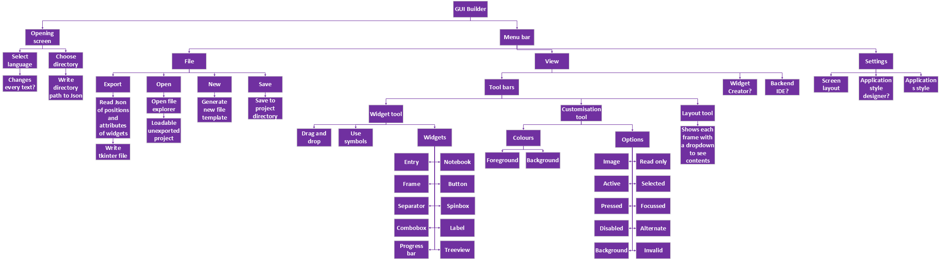

Justification for decomposition of solution

Opening window
This module is required to initialize the tool and set up the user experience as this will help to make the loading process smoother when the tool is opened in the future as it will facilitate the following:
- Selecting a language
This method will give the user the ability to choose their desired language to use the tool as this will make the application more user friendly and more accessible to people from all over the world. If I have the ability to learn and install a new library, then I would be able to translate all the text in the application into the language they chose as that is why it is one of my limitations but even if I cannot do that, I may still attempt to make a basic translator for one or two languages.
- Choose main directory
This method will be used to let the user choose where all the project files are stored so that they are all organized in one place to make file navigation easy and quick. This will also allow the system to run smoother as everything is in one set place to make locating and loading files extremely easy. This also can allow the user to save the files to a cloud computing storage system to allow the programs to be readable from any device with your cloud storage account loaded.

Menu bar
The menu bar is split into multiple sections for each tab of the menu bar like file, view, and settings. These each have their own functions as they will be merely containers for methods and not methods themselves.

File
This part of the menu bar will deal with file storage and modification and exportation. This will allow the user to navigate distinct functions and files using just their mouse. This will improve the user’s experience and capabilities by the following methods:
- New
This will simply load a template project directory from the main program files into the users’ projects directory so that the construction of a new GUI can begin. This will be done in this way as it is very quick and efficient when setting up the main GUI under construction so that it can still be edited before being exported as a Tkinter python file.
- Open
A method is needed to be able to open these GUI’s that are not yet complete so an open function would be required to open a file explorer of sorts and choose a project directory that is to be modified and eventually exported. To do this I will have to research how to open a file explorer window in python as I do not yet know how to do this but when I complete making this method it will benefit the tool in many ways. This is because it will give the user the ability to edit files created many days ago as well as letting the user choose if they wish to download a file, they could open it in my tool from their downloads allowing for more advanced users to get most of the application.
- Save
This will be a difficult method to achieve as I need to find a good template directory for every project to be built from. Also I would have to find a way to store all of the positions and attributes for each widget that the user has placed on the editing suite as this will be challenging due to the method to do this requires that I save the data to a Json file and then I would have to read from the Json file to put the widget on the screen unless I can find another way to drag and drop widgets using key binds. But once the file storage system is set then I should be able to import the data from the most recent save when the project is opened and then save the data after some work has been done to the same location with new tweaks. This will improve the tools function as it allows the user to partially complete a project and return to it at a later date or even complete part of a GUI then send it to a collaborator to complete other sections of the project.
- Export
This method will be one of the most difficult but most important methods in the project. This is because this makes it different to all other similar projects as no other GUI builder application gives the user the ability to export their GUI as a python Tkinter file. This method will successfully achieve that by reading the Json file with all the widget positions and attributes and by an algorithm I will detail later it will create text that can be written to a .py file and create an exact copy of the GUI designed by the user.

View
This tab in the menu bar allows the user to mold their editing experience to their wants and needs as this tab allows the user to show any of the tools, they have access to or not show any of those tools. This tab may get more methods through the course of the project as there may be more little features, I could append to the project’s construction process. Therefore, this tab on the main menu bar will use many methods to complete these functions like the following:
- Show widget tool and Show customization tool and Show layout tool and Show widget creator tool
Each of these tools can be shown by checking or hidden by unchecking a checkbox as this allows the user to decide which tools they wish to use at certain times. This gives the user more customization and the ability to mold the user experience to how they can design GUI’s best (the details of each tool will be explained later).
- Show backend IDE?
This is a potential feature (shown by the question mark) that gives the user the ability to open a Tkinter built text editor that acts as a basic IDE so that the user can program the backend of the GUI like the function of each button in unison with designing and formatting the widgets on the screen. In the future if the tool got the ability to allow multiple users to edit the same project simultaneously then this feature would allow the whole team working on the GUI to help each other and get a project done much quicker and smoother due to each communication and editing.

Settings
This tab of the menu bar gives the user the power to adapt and construct an editing experience that will improve productivity very quickly. As this lets the user change the style and look of their editing platform. This would not only teach them how to change the styles of a Tkinter file, which could be a good introduction to the role. But it also gives them the ability to make their working life how they want to be to let them have more fun and creativity when producing screens that may be seen and used by the whole world. This is done through the following features:
- Layout manager
To give the user the experience promised this tool will let the user decide if they want tools at the left or right of the editing screen as this means that the user can decide what type of layout they choose to have which will make their editing tool different to anyone else’s. These tool bars can be filed with the tools described below by showing them on the view menu and then dragging the tools by their tabs into whichever tool bar you want. In these bars the user also has the ability to take up the full bar and have two tools on the same bar but different tabs or they can have both tools sharing the space in any ratio desired by the user as long as the size isn’t edited below the tool in questions minimum width or height.
- Application style
Every designer and artist have their own desk, and they have their paints and paint brushes in various places compared to each other with some painting in acrylic whilst others paint with water colours. This element of design happens with designers drawing plans so why can’t it happen for digital designers. So, this feature will give the user the ability to choose from preset styles in Tkinter or imported styles as this lets the user make their tool their own by having it neon colours or black and grey or however they would prefer. This will be done by the tab having a dropdown containing each preset styles which the user can click to change everything but the current project into that style. If the user does wish to import a style from another programmer or create a style externally then there will be a directory in the main program directory that will contain python files for each preset style.
- Application style designer?
This potential addition into the tool will be a feature that pops up a styling window which allows the user to either see a visual representation of ttk styles by being able to edit each widget with your mouse which will be interpreted by the program and then converted into python and ran on the main editing suite class to give it all a new style or the user can click the other tab and see a IDE with a template for a style already laid out. This lets a knowledgeable user design a new editing style quickly without the hassle of remembering certain syntax. This would however be an extremely complex feature to add to my tool so will almost definitely not be a feature in the final product, but it may be in future iterations of the project.

Usability features

Opening screen
The opening screen will be a small and simple window projected the first time the tool is run on the device. This will have the title and a brief introduction to the software with an entry box to type in the path in which the user wants project files to be stored which will also have a file icon on the right of the entry box that will be used to project a file explorer that can be used to choose a specific path to save to. Underneath this there will be another entry in the form of a dropdown that will give the user a choice of languages to choose from which will initially just be English but if multiple languages are implemented into this then as soon as a language is picked from the dropdown then the opening screen will automatically update. Then at the bottom of the screen there will be an ok button to continue to the tool. These different interactions the user can perform will make the tool very user friendly as the user will instantly get the choice of where to store files which could be something the user needs to know. This could be because they must export files and transport them between devices so by having the choice for a projects path or just being made aware of this location as this makes the tool easier and more elegant to use in a business setting.

Main screen
In the main part of the tool the screen will be partitioned into 3 sections as there will be a main editing section in the center which takes up most of the screen initially with 2 tool bars taking up equal space either side of the editing section as well as a menu bar at the top of the screen.

Main screen – main menu
This part of the main screen will have multiple tabs each which can be hovered and clicked to drop down their respective contents as this gives the user a familiar feeling due to most software’s having as similar design of contents at the bottom and a main menu at the top with quite familiar names. This lets the user get familiar and comfortable with the application quickly which will help to allow them to use to the tool to its full potential as they could quite easily assume what features will be under the main menu tabs without looking.

Main menu – file
In this section of my tool the user will be able to organise their projects as they will have the choice of new, save, open, save a copy and export. These will all be buttons in dropdown menu File that can be clicked. When the new button is clicked a new blank canvas will be loaded into the centre partition of the window so that the user can begin creating their GUI. When the save button is clicked a subroutine will run that will save the attributes and location of each widget to a Json file so that all the data can be loaded again. When the open button is clicked a file explorer will open and the user will either click the project directory they wish to open, or they can enter the directory and there will be a file called OPEN_ME.txt that can be opened to tell the program which project the user wants to open. When save a copy is clicked an exact copy of the project directory will be saved to a location of the user’s choice by using a file explorer to choose. Finally, when the export button is clicked a subroutine will run that will analyse the location of every widget and weather it is on top of another widget or bellow. Once it has done this a new python program will be generated that when ran will be an exact replica of the GUI built in the tool. This section of the main menu works to allow the user to create or edit GUIs and through the use of buttons and file explorer windows it will be made to be easy to understand as it will hopefully resemble most other applications as many have a file tab in the main menu.

Main menu – view
This tab of the main menu gives the user the ability to change their editing environment by deciding what tools they require and whether they want them to be on the main window or broken off. The way this will be done is by having the View tab drop down all the tools and when you click on any of the tools two tabs will pop out from the right one will say show if it is not currently on the screen or hide if it is. The other will tear off and by clicking this the tool of choice will be separated from the main window and put into its own window. This gives the user complete control over the look and feel of their GUI builder which will hopefully help them to create GUIs at a quicker pace as they know where everything is. I will achieve this with the addition of a Json file in the main program files that will store the current style; the order of the tools on the toolbar; whether each not currently displayed tool was previously on a toolbar or in its own window and the size of the toolbars and editing section of the window.

Main menu – settings
In this tab the user will be given the ability to alter their GUI building station to how they desire as there will be a tab that drops down to contain different styles of tool bars as you could choose to have one on the left or the right or both or maybe top and bottom but that is not for definite. This will be useful as it allows the user to change the layout of the window to be how they would work best on. Also, in this section of the main menu there will be a dropdown that gives the user a choice of styles for the window not the GUI that is being built as well as the ability to import a style or maybe create a new style in the future. This helps the user to get better experience as it allows them to create their own environment to work in which works best for them.

Main menu – help
When the user wishes to ask for help or find out some details about the application this is the tab they will turn to. This is an obvious addition as it is common for a tool to have a help tab that is very easily noticeable as this one will be. This will contain simple guides to teach the user how to use the application so it will begin with quite simple ones to demonstrate the idea. This will be done by clicking the guide’s dropdown then selecting one of the choices. On doing this a window will pop up that will be remarkably simple with text and maybe some images that may require a scroll bar. This will not be massively detailed, but it will have enough detail so that the users can read this and understand the different sections of the application. The about tab will bring up another window containing information about when the application was created and who by and for what purpose to give the user the ability to research into the tool. Then finally the contact us section of the help tab will contain information about how to contact the creators of the application if there are any queries, suggestions, or complaints. This is very user-friendly as it gives the user the ability to reach out to the creators as well as allowing them to expand their capabilities with this tool.

Main screen – tool bars
Each tool bar at either side of the screen will have a couple tools already loaded into the toolbars as use of the software is difficult or complicated without a few tools. Each tool is presented as a tab in the toolbar and so can be clicked and held to drag the tab either to a different toolbar of a different section of a toolbar or as its own window if dropped in a section not highlighted as a section of a toolbar. Tools can be removed by clicking an x that will show if hovering over the tab or by accessing the view menu. Toolbars do begin as taking up a set percentage of the screen each, but this is easily adjusted by grabbing and pulling the borders of any of these toolbars. Each tool will have a range of different interactable features. These toolbars are very user-friendly as they give the user a large amount of customization as to how they wish for their working environment to be laid out and presented therefore allowing the user a quick and easy job when building GUI’s.

Tool bars – widget tool
This section of the screen will be displayed instantly once a project is created as it is needed to be able to create a GUI. However, in future iterations, I may make key binds to do every tool that can be done in the widget tool. This will be compromised of many buttons all with icons not names as icons are easier to understand by anyone who speaks any language. This will then be used by a user clicking and holding on a button then dragging the mouse onto the main editing screen and dropping the chosen widget onto the GUI currently under construction.

Tool bars – customization tool
This tool will be automatically loaded onto one of the toolbars when the program is run as this will have entry boxes, combo boxes, sliders, and many other widgets to select options as this will change the style of the selected widgets. Again, this can be done without the tool as you can right click on a widget to change all its attributes but by pressing any widget you could also use the tool to make it easier to see and use. This makes it very user-friendly as it gives the user an extensive view of every single attribute that they can customize as well as the option to change many widgets allows the GUI to have a more prominent theme.

Tool bars – layout tool
In this section of my application there is a tool that the user can choose to have on one of the tool bars, but it will not initially be on either of the tool bars as it is not required in the development of a GUI, but it may be necessary for a more advanced programmer as this tool will show an abstracted version of the GUI. It will do this by having the root window at the top with an accordion style dropdown that then will contain all the frames and any widgets that are directly on the root window. This will continue until each frame and widget is presented in the embedded accordions as this may be necessary to programmers due to them having to export the GUI as a python program and then they would be required to build a backend with all the logic required for the GUI to do what it was made for and with the knowledge of how to GUI was built in a simple abstracted format then the programmer could program the backend quicker and easier. This shows how it works to help the user as it not only presents the whole GUI in a simple abstracted way, but it could also be used to show multiple GUIs working together in later versions of this project.

Main screen – editing section
In this section of the screen the user will drag and drop widgets onto the currently opened file so when a file is opened it will appear as a tab on the top left of this section of the screen which can be closed or dragged out to be in its own window. This section is the most important section of the tool as it shows the user exactly what the exported python Tkinter file will look like therefore simplifying the GUI building process through dragging and dropping. This makes it very user friendly as there will be no miscommunications between user and application as whatever the user desires to put on the screen will be put on the screen.

Classes
In this section of my report, I will explain each class in the program as it is programmed in an object-oriented fashion.

App
This class of my application is the main object that handles every main menu command as well as all of the key binds and all of their function. This gets parsed the main canvas object as well as the toolbar objects and then the coordinates creating saving or opening files as well as handling any button presses or clicks on either of the toolbars or the main canvas.

Opening
This section of my app handles the first time the program is run that the main window will open but then a secondary small window opens that gives a brief example of the tool and then asks the user to choose a language and a path to store all of the project files. This can be found by either entering it in the entry manually or by clicking a browse button and opening a file explorer to help choose a directory to store projects in. This window then closes once the apply button is pressed as long as there are no further errors with the data then the Top-level window closes and allows the user to select the main window again.

Editing
Once an object of this class is created the main notebook in the center of the screen and this handles the currently open projects canvas which is ratioed to fit 500px in one dimension. And then all widgets are displayed in this same ratio on the canvas so that when the real python file is exported it fits the same ratios with the chosen dimensions.

Toolbar
There will be two toolbars created that each could have their own tools out of widget, customization, or layout. And these toolbars are also notebooks that give the user the choice between using each tool or hiding or showing each tool if they wish to. These will create and house the tools so all communication between root and the tools must go through these objects.

Customization
This tool will use the static function outside of the classes to create rounded rectangle frames for each of the attributes that can be changed for the selected widget. This will be done by having each option with just the title and no entry or progress bar or colour picker as this will be how they will appear when they are disabled. Once a widget is selected then the attributes that widget possess will be activated making the rounded rectangle frames expand to show some way to input a value and then another rounded rectangle adapted to be an apply button. This apply button will then find which widget is focused on, then edit the attributes of the widget in canvas and in the project.

Layout
This tool is an extra help to the user by having a round rectangle for each project that has root then the main canvas then any widgets in a dropdown fashion maybe either an accordion style or just lines separating each layer. If any of the widgets are pressed from the layout tool, then they will also be selected for customization.

Widget
In this class of the project the widgets will be chosen to be put onto the main canvas so the user can click and hold on a widget that can be chosen from and drag it into the canvas and if it is dropped outside of the canvas it is deleted but if it is over the canvas then it will be added to the main canvas and to the project.

Project
This class will instantiate an object that holds all the basic data for a project file as well as any data collected from a current project file, and this will coordinate the reading and saving of a project. This is vital in retrieving saved projects to continue editing or when exporting a project as a python Tkinter file.

Algorithms

Exporting
One of the major sections of mt project is the ability to create any design for a GUI and then have the option to export it as a python Tkinter file. This is usually a process that would take hours of designing each widget and placing them all using a various choice of organizing choices. So, using this exportation algorithm my tool will turn a canvas of widgets into an exact replica whatever screen size chosen.
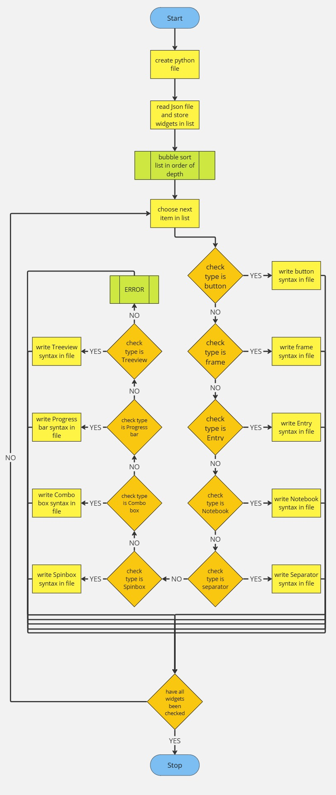

Saving
This algorithm will read all the widgets out from the project object and then it saves all that data to the correct project directories Json file. This is formatted before being dumped into the file and this algorithm allows the user to finish working on a file then come back later and carry on where they left off.
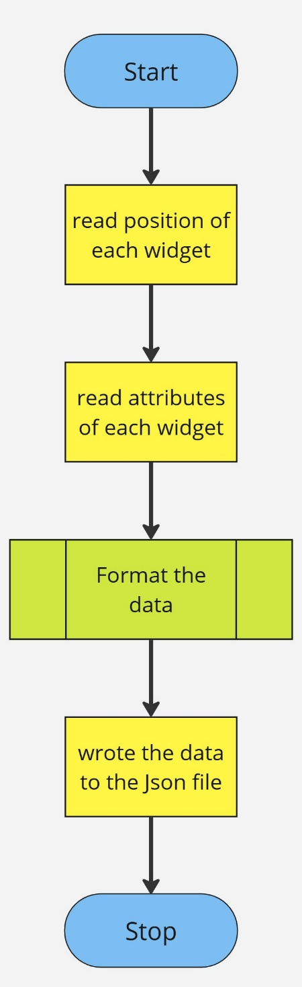

Loading
When the user comes to making a new file or opening a file as both work the exact same it’s just that when a new file the data that is being loaded is just a blank canvas with no widgets currently in it. This works by having every potential attribute stored in each widget in a saved file and then when it is loaded each widget is decided to be one of the potential ones and then all the attributes are applied to this new widget.
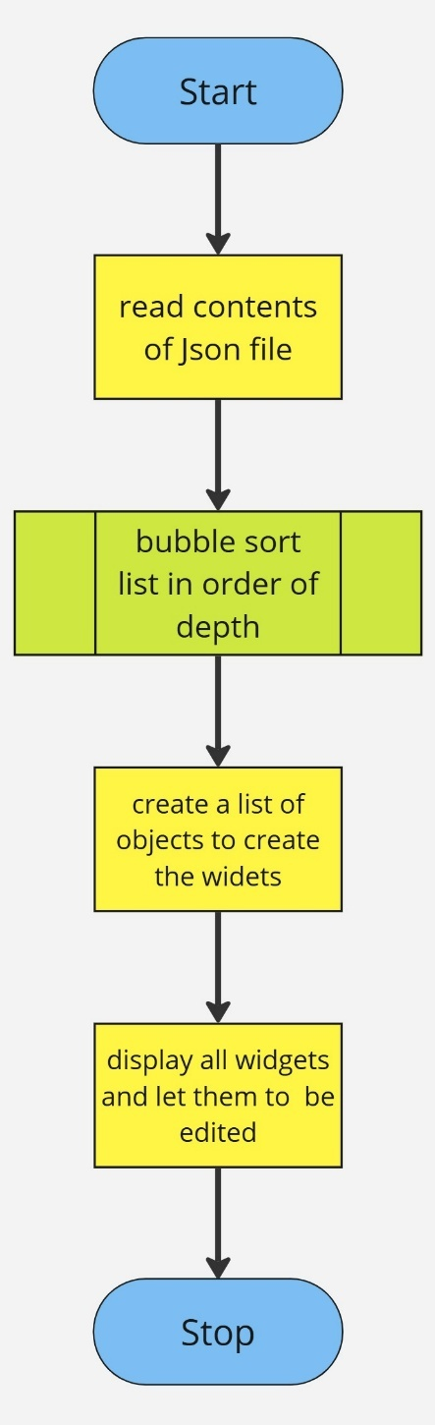

Adding widget
This is done in an extremely straightforward process by splitting the addition of new widgets into a click, a move, and a release. In which on the click the widget to move is created identically to the one clicked and spawned in line with the clicked widget. Then when it is dragged then widget. Then when it is dragged the moving widget is positioned so that the mouse is always at the point the clicked widget was clicked. Then when it is released, the coordinates are checked to see If it is over the canvas when being dropped as if it is then it will be added to the project and to the main canvas but if it is not then it will instead be deleted so that it is not in the way anymore.
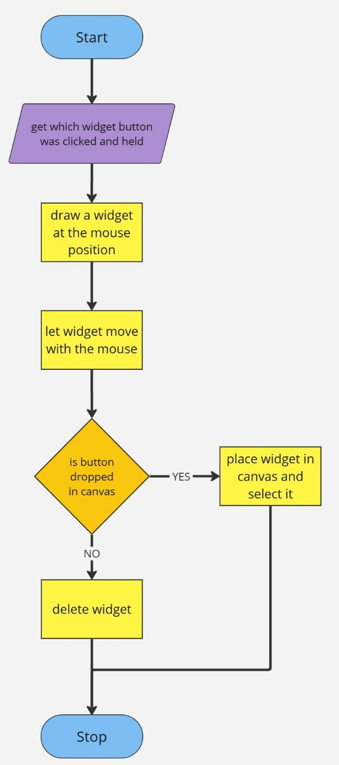

Opening screen
This will only open the very first time that the application is opened as this will appear just after the main window is opened and will show as a Top-level window that opens and tells the user a brief description of the tool and it also gives the user the opportunity to enter a chosen language as well as a path to store all of the project files. Also, as an extra feature once the opening screen has popped up the user will not be able to click or use the main screen until the apply button is pressed and there are no errors.
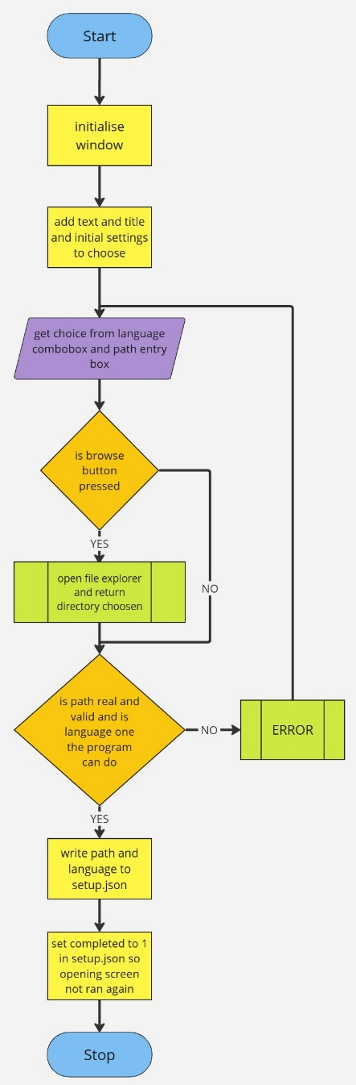

Editing widgets
An algorithm is required for this process as to edit a widget attributes the user must first click the widget in the canvas or on the layout tool to select it and then the customization tool will open its rounded corner frames to reveal progress bars or entry’s or colour pickers or choose attributes. This will also disable certain attribute pickers depending on the type of widget chosen. Then the user will change all of these and then click another rounded corner rectangle that works as an apply button binded to a method in the app class.
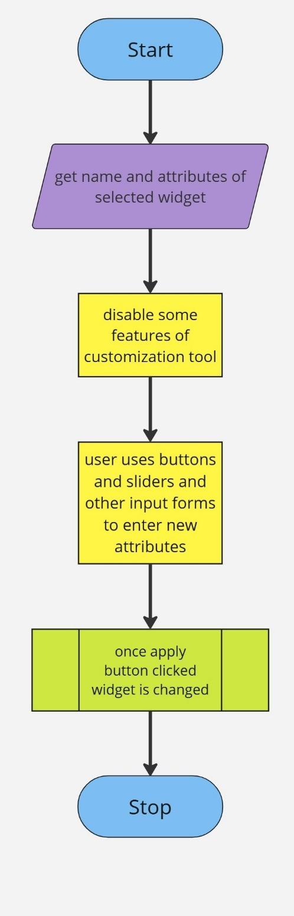

Main menu
In this section of the tool the user will have the choice of using many menus and commands embedded within to help use the tool. This algorithm works through the options the user has and the outcomes on the project based on those choices like the ability to change the tools you want to show and open or export a new project.

Key data

Out of classes
Variable | Data type | Explanation | Justification
SETUP | string | This is the main file housing initial setup data | This is used to fetch theme data and write path and language
root | Tkinter object | This is the main window to write to | I use this to create the screen
initial_setup | dictionary | This is the read version of the setup file | This is used to store the setup data in a format I can read
left | list | This holds data about the last time the tool was open | This is used to get positioning or what tools were in which toolbars
right | list | This holds data about the last time the tool was open | This tells me where the right tool bar was and what was in it
master1 | Tkinter object | This is made to house the left toolbar if it was detached the previous time | This is required as it makes a top-level window to show all of the data
master2 | Tkinter object | This is made to house the right toolbar if it was detached the previous time | This is required as it makes a top-level window to show all of the data
toolbar1_frame | Tkinter object | This is a Tkinter object used to house more Tkinter widgets | This is used to hold all of the widgets in the left toolbar
toolbar2_frame | Tkinter object | This is a Tkinter object used to house more Tkinter widgets | This is used to hold all of the widgets in the right toolbar
editing_frame | Tkinter object | This is a Tkinter object used to house more Tkinter widgets | This is used to hold all of the widgets in the editing section
main | app object | This is an object of the app class that creates and handles the whole of the program | This is required to run the program
toolbar1 | toolbar object | This is an object of the toolbar class that creates an empty toolbar on either the left or right | This is required to put widgets in the left partition of the window
toolbar2 | toolbar object | This is an object of the toolbar class that creates an empty toolbar on either the left or right | This is required to put widgets in the right partition of the window
editing_section | editing object | This is an object of the editing class that adds widgets to the central reservation of the window | This is required to populate the central part of the window

Validation
In this application there will be features that the user could attempt to use in the wrong way in or for the wrong widget so to prevent any inconveniences or difficulties I will add many different validation statements. These will prevent some errors from occurring by stopping the user from causing certain errors that can be avoided.

Disabling customization features
This validation is used to disable certain entry’s in the customization tab of a toolbar as most widgets wont use al of the attributes you can change in the customization tab so in order to not have redundant data some of the entry boxes are disabled not allowing user to edit them.

Disabling certain menu bar features
This validation is used to disable some tabs of the menu bar based on what they would achieve as one of the tabs is about the IDE that was a limitation of my project in my analysis section. This will probably not be created so I disabled it until it could be so as to show where it will be run from in the future.

Opening the whole directory to load a project
This validation is required as I decided that I could not create my own type of file so as a substitute for that I get the user to create a directory for each project that will house the Json file that holds all of the data in the previous save of the project. This is a flow chart showing how this layer of validation works.
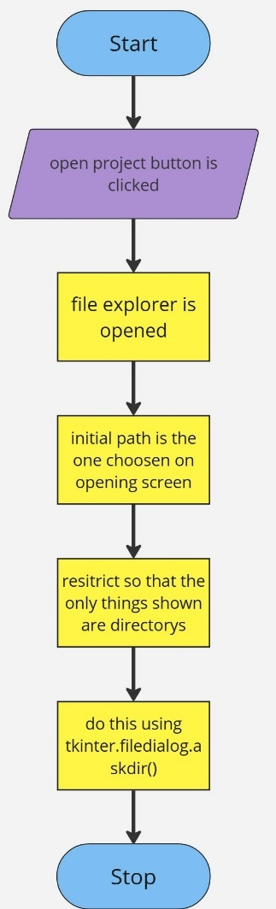

Initial testing data

Developing the coded solution
In this project it heavily relied on the programming, so it was in my best interest to structure my project in the best format possible. I achieved this through the use of object-oriented classes and methods.

GUI design
The main GUI design came out exactly like u had planned with the 3 main sections cut out of the main window to allow the user full access to all of the tools available at once. It had a nice system allowing multiple open projects at once in the central reservation so that the user can either build one project with 2 GUIs or 2 separate projects. These said GUIs are also built with the tools on the left and right side of the window which are also notebooks containing all 3 tools to begin with but that could change if the user wants a different layout. All three tools have the same design as a darker background with rounded rectangles for different functions like the widget tool has a rounded rectangle for each widget you can choose, and it allows you to drag and drop these as well. In the Customization tool the rounded rectangle’s function is used to display each attribute that can be edited depending on what widget is selected for Customization. And in the layout tool a rounded rectangle is used to show the format of the GUI.

Programming

Create opening screen
I started with the opening window as I thought it would be a quick and easy way to start designing and building thus GUI builder. The main idea of the opening screen was to make it open the setup. Json file and see if the opening screen has been run yet and if not then it is now. It currently is being run by opening a window and then making the user close the program before having to go back in and open it again to get to the main window. This hasn’t been programmed the most efficiently but as my original intent was just to get it to run before the main program it achieved that goal.
Test data | Expected result | Actual result
Completed = 0 | Run the main window then opening screen and locks out main window | Runs opening screen and destroys itself so must be opened again by the user
Completed = 1 | Opens main window | Opens main window
Setup. Json is empty | Run the main window then opening screen and lock out main window | errors

Populate opening screen
I decided to organize the opening screen into 4 quarters, but I made them not equal to add a but ore character to the tool. It displays a title to the top right and a short description bellow with a set statement asking the user to enter in some data with said entry quarter bellow. To use the entry quarter the user clicks the drop-down box and selects a language and then either enters a path manually or clicks the browse button to open a file explorer to get the choice to look for a path to save all project files.

Test data | Expected result | Actual result
Enters language | Language s entered into setup. Json on apply button click | Language is entered into setup. Json on apply button click
does not enter language | Opens error message | Opens error message
Enters path | Path is entered into setup. Json on apply button click | Path is entered into setup. Json on apply button click
Enters invalid path | Opens error message | Opens error message
Does not enter path | Opens error message | Opens error message
X button clicked | Opens opening window next time program ran | errors

Main screen layout
I decided to opt for a screen split into uneven thirds and in later versions would come up with a way to change this design so that each section can be stretched or shrunk. I had to do this by using notebooks which as they are ttk widgets not Tkinter it added an extra layer of difficulty. This is because the only way to change the attributes of a ttk widget like changing the background colour you have to create a custom style. In future iterations of thus tool as well I would aimed the styles to contain formatting and attributes for every widget so that there would be no need for handling colours at all. Also, I began building a system where the user could detach the toolbars but as they got extremely complicated, I will achieve that goal in later versions of thus tool.

Menu bar
The menu bar is split into file, view, settings, help and about us. These tabs are used to navigate the tool and take advantage of all of its features. Like how it the file tab you have the majority of the main functions needed to use the toll as in there is the export and open and new and save functions. These are built into menus inside of the menu bar as to add a good structure that makes sense and is easy to understand.

Making a new file
In order to make a new file I tried to plan ahead and use the same method in the editing class as opening a new file will use. So, to make this function I first opened a file explorer for the user to choose a project name. Then to display the blank canvas I created a project object that was completely blank that then opened a top-level window to ask the user the width and height of the height of the new project. While these dimensions are being filled out I froze the main window so that the user cannot interact with it and can only edit the dimensions window. Once valid data is entered the project is updated and then displayed on the main canvas.

Opening a file
To open a project is very similar to creating a new project so to achieve this functionality first a file explorer is opened to choose the correct directory as I preferred to chose a directory not the Json file. The once a valid directory is chosen a project instance is created that reads from the Json file to get its required data. This is then loaded straight into the main canvas, and it is reformatted based on the window size. This is because in order to fill the screen at least one of the dimensions of the canvas is 500 pixels so to account for this all x and y positions of widgets are multiplied by this ratio and so is the font. This ratio is required so that once a file is exported it looks exactly the same as it did in the tool.

Rounded corner canvas
This was purely a design choice as I believed that the tools needed a bit more character and so I researched into frames with rounded corners, and I found a snippet of a program that creates a canvas with a custom polygon with coordinates in order to simulate Rounded corners of a rectangle. U implemented this by making each Rounded corner “frame” be a main frame containing a canvas which has a polygon drawn on it and then a label at the top of the rounded frame then a line drawn underneath the label with either nothing for the collapsed frame or some other widget.

Selecting widget
This section of the project was surprisingly one of the more complicated parts as I struggled greatly to bind mouse clicks to widgets in a canvas as I required different objects communicating so I found the best way to do that was to bind every mouse click in the app class as it was the only class that had access to root. So, to do this it meant I had to find a way of returning the instances of all widgets on the canvas or in the widget tool. Then I would bind a mouse click to this widget and link it to a method in app that then had to communicate with different objects from app. But in the end the user could click to select a widget which becomes extremely useful in future sections of my programming.

Widget tool
The widget tool is one of the greatest parts of my project as it gives the user the ability to add or remove whatever widgets they want from their GUI without having to deal with the usual mess of creating and then placing, packing or griding the widget. I thought the best way to design this tool was to have rounded frames that have a dark border and a lighter background than the background of the notebook tab. This then was improved by having the widget name at the top of the frames and a small line to underline it and separate it from the actual widget which was in basic formatting and placed just underneath the line.

Dragging widget and dropping it
This was a very well thought out method to drag and drop anything. There are 3 steps clicking, then moving the mouse and then releasing the click. So when the click was done I ran a method that created a new widget called self.moving and then I placed it exactly where the clickable widgets were so that then I could also store the coordinates clicked. Then when it was moving, I placed it perfectly so that it was like as if wherever you clicked the click able widget in the tool is where your Dragging the widget from. Then on the realize I checked the location to make sure it was being dropped over the canvas and then added it to the project object and the main canvas.

Showing and hiding tools
To achieve showing and hiding tools I decided the best way was to not pack and unpack things in the tools themselves but instead I temporarily deleted the notebook tab while still preserving the tools object and which toolbar it was in. This also came with an extra layer of validation as I had to check if it was already shown or not or which toolbar it was originally shown in.

Customization tool
This tool is the most advanced one as it requires a widget to be selected and then it required me to handle many different frames as I believed the best was to create this tool was to have one frame with the collapsed design and one open one. So initially all of the collapsed ones are packed, and the open ones are pack forgotten. But then whenever a widget is selected depending on the type of the widget which attributes are collapsed or opened. Then all of the entries are filled with the current data and then when the apply button is clicked all of the contents goes through validation before being entered into, he projects and then the previous version of the widget being deleted and replaced by the new widget.

Layout tool
This tool is made to show the user what widgets are on the screen and in what order to show any overlaps. This is only going to be used by more advanced users as this is only needed when looking at overlapping or changing the variable name of the widget when it gets exported to a python file to make it quicker when programming the backend.

Exporting
This is a pivotal section of my program that is currently not finished but once it is this section will work by creating a basic format for the python file and then adding to this file by creating instances of each widget with their respective attributes. These widgets will then be placed in the correct x and y position based on the data stored about each widget and then there will be sections built for the main logic to go and for the button commands to be which will be empty for now.

Saving
This section was a mix of the app object working with the project object to save the data by dumping the current data into the Json file which is named to be the same as the directory as I could not figure out an easy was to create a new file type the directory is my file type. This assures that what a old project is loaded again it keeps all of the screen data as well s the widget data to allow the user to continue creating their GUI.

Changing themes
This is done through the settings tab of the main menu where the user can pick a theme and, in the future, can design their own themes. This then is set by changing the setup. Json file to have the current theme be whichever one was just clicked. To reload everything is complicated as it requires everything being killed and then new object instances being created to read all of the colours.

Evaluation

Final testing

Usability features

Evaluation of solution compared to success criteria

Maintenance

Appendices

Code appendix

